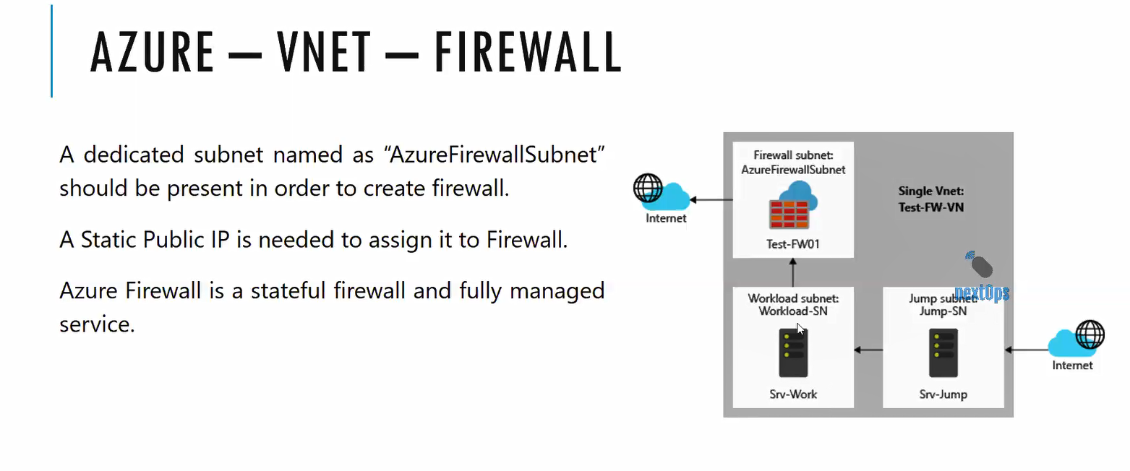

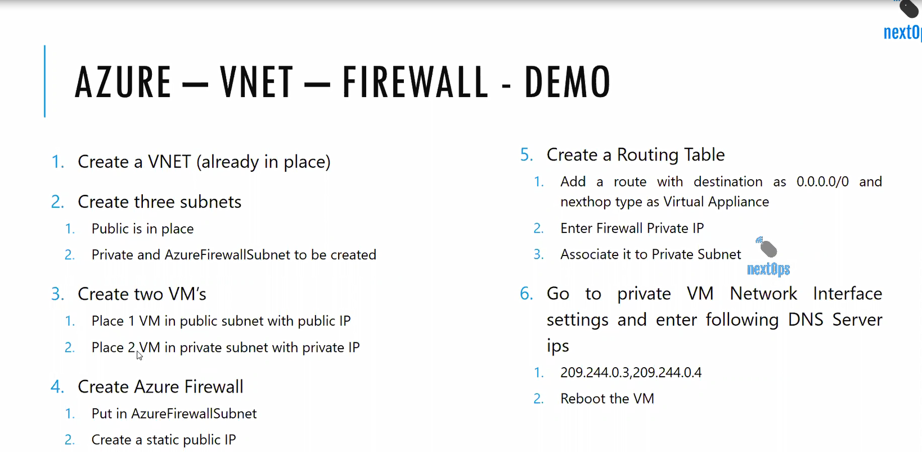

Through 1st VM we are connecting to 2nd VM via jump box

Configure DNS in Network interface for 2nd VM which is private (Assign Public Ips)

And in the 2nd vm after logging if you type ipconfig and nslookup then we can see our assigned Public Ips